**DAY 3 - API INTEGRATION AND DATA MIGRATION**

**Steps for Day 3:**

1. Understand the Provided API:
2. • Review the API documentation for your assigned template.
3. • Identify key endpoints such as: o Product listings (e.g., /products)

**Product.ts:**

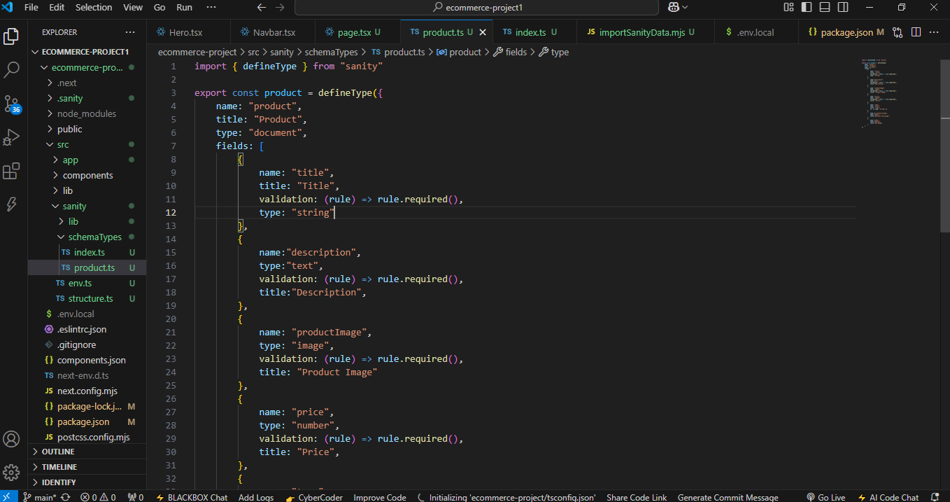

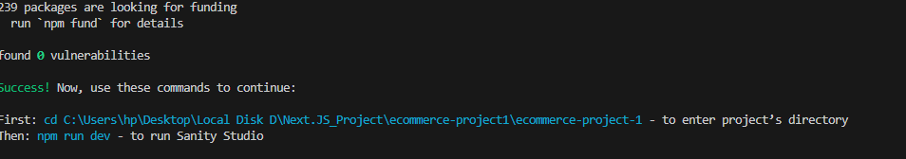

**2. Validate and Adjust Your Schema:**

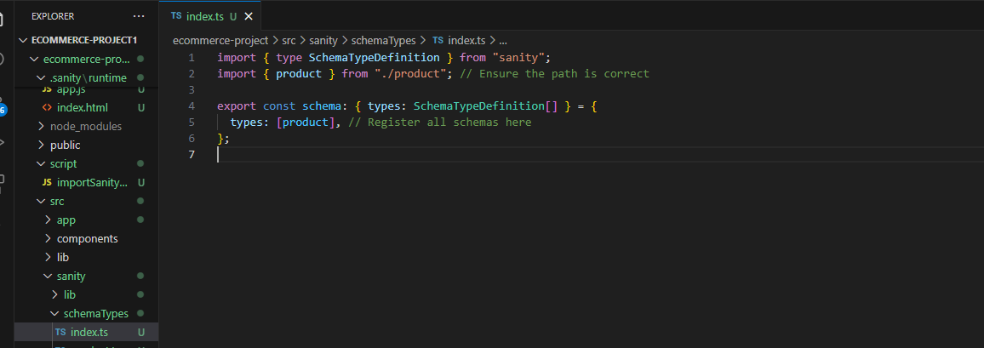

1. **Data Migration Options:**

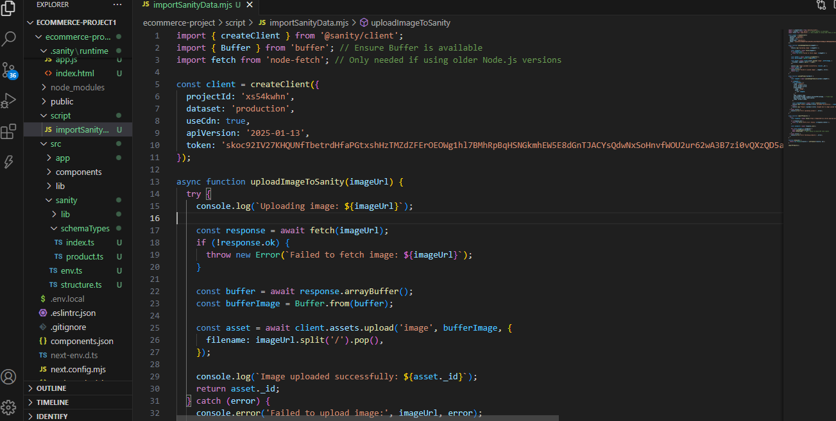

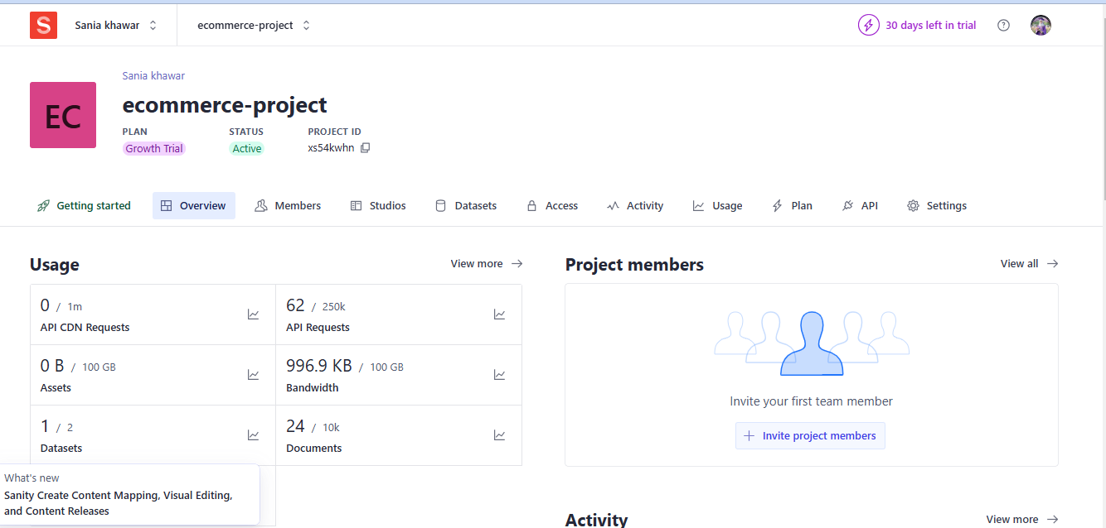

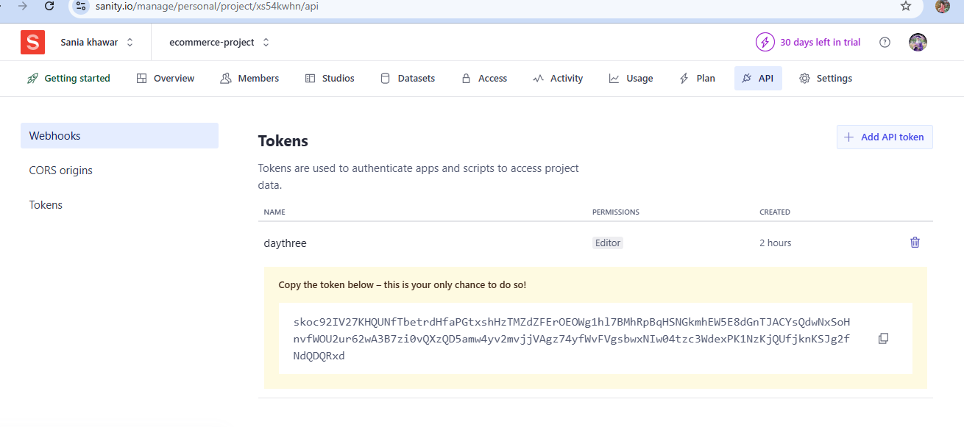

**Studio/Product:**

